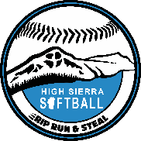
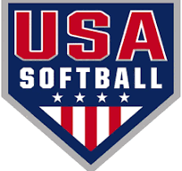
HIGH SIERRA SOFTBALL
SPONSORSHIP OPPORTUNITY
Dear Community Leader,
Thank you in advance for your interest in supporting High Sierra Softball. Support from our local businesses and community members has helped our league to become a community partner. We are a 501(c)(3) non-profit organization, and as such, your generous donation is tax-deductible. We thank you for your consideration in supporting our growing program and its young aspiring players! You will see below that we offer several sponsorship levels to accommodate your generosity.
ur generosity.
HOME RUN: $750+
- Logo on League website
- Logo on banners (2) at Field of Dreams
- 2 email mentions with logo from league
- 4 social media mentions
- Opening Day acknowledgment

TRIPLE LEVEL: $500
- Logo on league website
- Logo on (1) banner at Field of Dreams
- Logo on banner at field of dreams
- 1 email mention with logo from the league
- 2 social media mentions

DOUBLE LEVEL: $250
- Logo on website
- Logo on (1) banner at Field of Dreams

SINGLE LEVEL: $155
- Sponsor one player’s registration fee
- Logo on league website

ADD ONTO THE ABOVE: $75
- Logo on sweatshirt

Please reach out to our Treasurer, Chelsey Mora, via email at chelsmora3111@gmail.com to help assist you with your decision and/or with any questions you may have.
Thank you for your consideration supporting High Sierra Softball. Together, we can hit it out of the park!!

