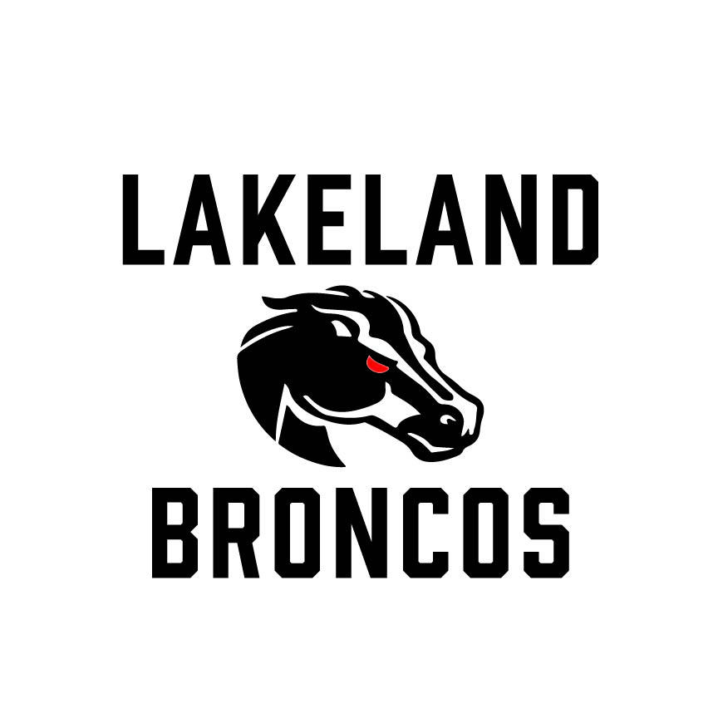
Lakeland Broncos Board Meeting Minutes

August 25, 2026

Meeting Overview
- Meeting called to order at 6:00 PM
- Previous meeting minutes were approved

Program Updates

Mum Fundraiser
- Mum sales are underway as part of our fall fundraising efforts.
- The online store closes on August 28.
- Mum pickup is scheduled for September 8 from 5:00 PM to 7:00 PM.
- Thank you to all families who continue to support Broncos fundraising initiatives.

University of Michigan Experience
- Planning continues for the November 1 University of Michigan event.
- Ticket information is expected soon and will be shared with families once finalized.
End-of-Season Banquet
- The Broncos Banquet is scheduled for November 14 and 15 at Bakers in Milford.
- Ticket pricing and purchase information will be finalized and communicated following the September Board meeting.

Cheer Updates

Pink Out Day
- Pink Out bows have been completed and will be distributed to cheerleaders.
- Thank you to the volunteers who helped make this event possible.

Cheer Fest & Showcase
- Cheer Fest planning continues for the upcoming season.
- The Broncos Cheer Showcase is currently planned to be held in the auditorium.
- The organization continues exploring opportunities to expand resources and facilities that support our cheer athletes.

Treasury Report
- Total Funds: $65,161.23
- Checking Accounts: $47,833.00
- Savings: $13,833.96
- Certificate of Deposit (CD): $10,549.11
- The Board approved renewing the organization's Certificate of Deposit for an additional 13-month term.
- Admissions, concessions, sponsorships, and fundraising efforts continue to provide critical support for football and cheer operations.
- The organization remains in a strong financial position and continues investing in athlete safety, equipment, facilities, and program enhancements.

Season Planning

Homecoming
- Homecoming planning is underway.
- Team UDs may begin coordinating plans and communication with their families.

Picture Day
- Reminder that Picture Day is scheduled for August 30, 2026.

Game Day Experience
- The Broncos inflatable helmet entrance will continue to be featured at home games.
- Broncos merchandise will continue to be available during home games.
- The Board remains focused on creating a fun, positive, and memorable experience for all athletes and families throughout the season.

Volunteers & Support
Additional volunteers are still needed throughout the season for:
- Admissions
- Concessions
- Field setup and cleanup
- Game day operations
Thank you to all of our families and volunteers for supporting Lakeland Broncos Football and Cheer. Your time, energy, and dedication help make our program successful.

Board Update
- The Lakeland Broncos Board welcomed Shantelle Brast as our new Event Coordinator.
- Shantelle will support Broncos events, fundraising activities, and social media initiatives throughout the year.

Adjournment
- Meeting adjourned at 7:10 PM

