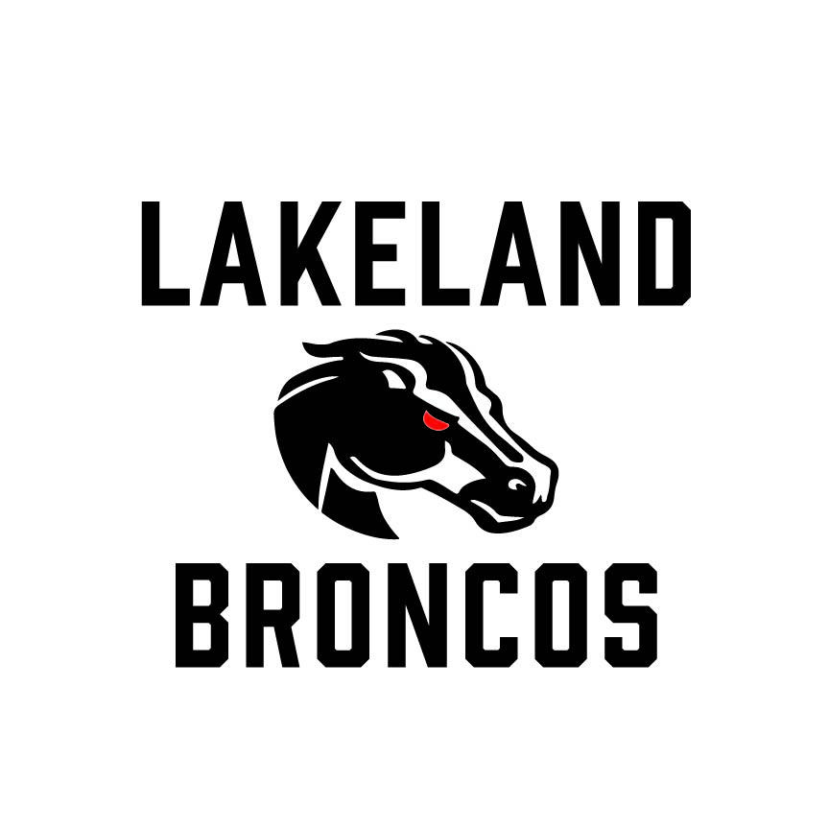
Lakeland Broncos Board Meeting Minutes

August 25, 2026

Meeting Overview
- Meeting called to order at 6:28 PM.
- Previous meeting minutes were approved.

Program Updates

End-of-Season Banquet
- The Broncos End-of-Season Banquets remain scheduled for November 14 and 15, 2026, at Bakers in Milford.
- Planning continues and additional ticket information will be shared with families in the coming weeks.
- Families participating in both football and cheer will have opportunities to celebrate both programs.

University of Michigan Experience
- Planning continues for the November 1 University of Michigan event.
- Tickets are currently available.
- Additional details regarding event activities and logistics will be shared as they become available.

Ford Field Youth Football Experience
- Lakeland Broncos athletes have been invited to participate in a special youth football experience at Ford Field on October 25.
- Football and cheer participants will have the opportunity to take part in the event.
- Additional details will be communicated to eligible families.

Cheer Updates

Cheer Fest
- Cheer Fest preparations are in full swing as teams continue practicing and preparing for the event.
- Event materials and awards have been received and planning remains on track.
- We are excited to showcase the hard work and dedication of our cheer athletes.

Cheer Equipment
- The Board approved the purchase of new competition pom-poms to enhance the cheer competition experience.
- Existing pom-poms will continue to be used for games and practices.

Senior Recognition
- Plans are underway to recognize our 8th-grade football players and cheerleaders during the season.
- We look forward to celebrating these athletes and their contributions to the Broncos program.

Championship & Postseason Planning

League Super Bowl
- Planning is underway for the league Super Bowl scheduled for October 31.
- Volunteers will be needed to support game-day operations and event activities.
- Additional information will be shared as plans are finalized.

Event Experience
- The Board continues working to enhance the athlete and family experience through special events, food vendors, spirit wear, and postseason activities.

Treasury Report

Financial Update
- Checking - $42,767.49
- Savings - $13,834.08
- CD - $10.549.19
- Total – 67,150.76
- The organization remains in a strong financial position.
- Fundraising, admissions, concessions, sponsorships, and merchandise sales continue to support football and cheer programming, equipment, facilities, and athlete development.

Volunteers & Support
Additional volunteers are still needed throughout the remainder of the season for:
- Admissions
- Concessions
- Field setup and cleanup
- Chain crew and game-day support
- Special event operations
Thank you to all of our families and volunteers for supporting Lakeland Broncos Football and Cheer. Your time, energy, and dedication continue to make our program successful.

Looking Ahead
Upcoming highlights include:
- Ford Field Youth Football Experience – October 25
- League Super Bowl – October 31
- University of Michigan Event – November 1
- Broncos End-of-Season Banquets – November 14 & 15

Adjournment
- Meeting adjourned at 7:20 PM.

